Date : 8-Sep-2026 8) Installation of OpenStack and creation of Virtual machines
Aim:
To install of openstack and creation of virtual machine in linux system.
Steps:
1)Update all the file in the ubuntu by sudo apt update
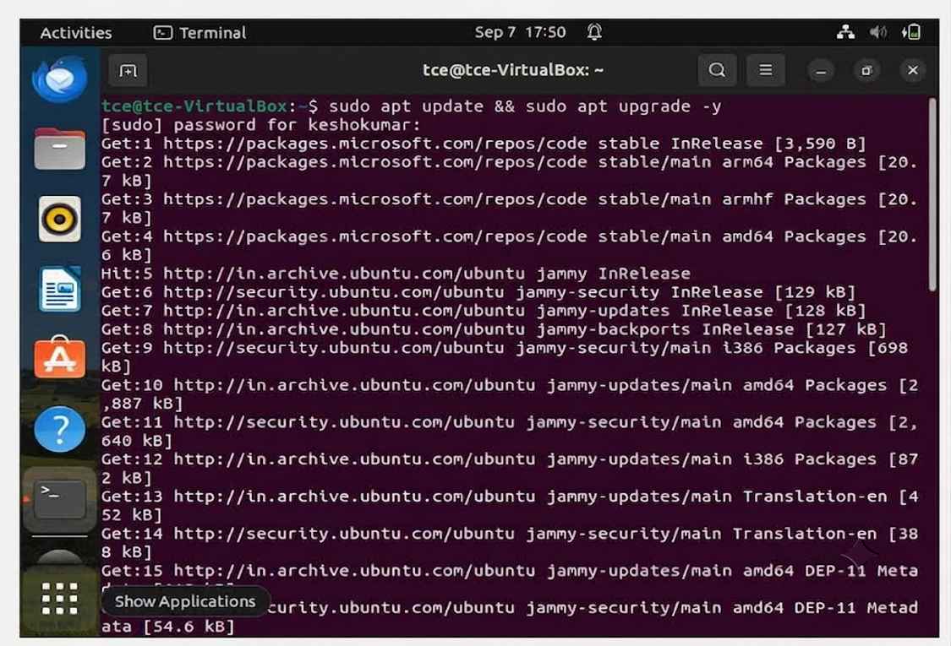

2) Install the packages to build the openstack
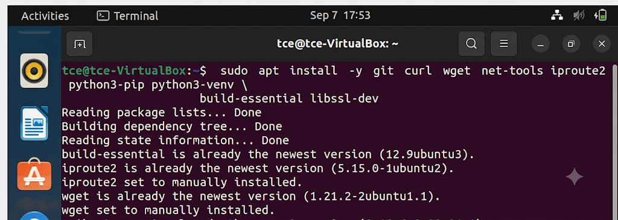
3) Add the user stack to the ubunttu especially for the openstack and give the sudo privilege for the user stack and add to the group
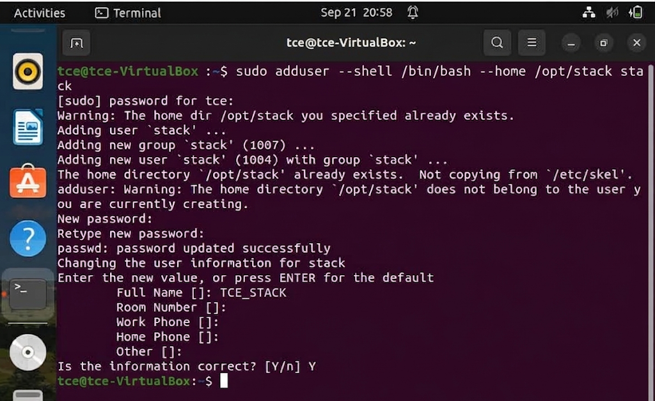

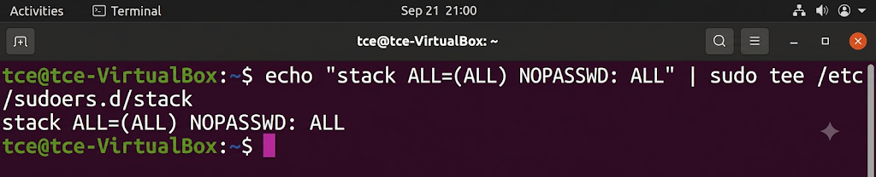
4) Set no password for all

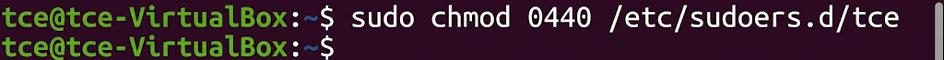
5)Give the privileges for the user stack

6) open the keshoo as sudo user by the command sudo su - stack
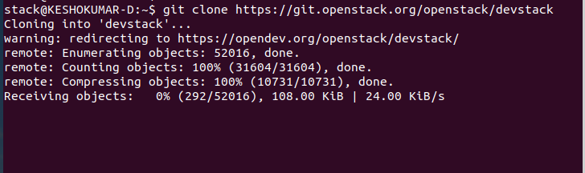
7)go to home directory and download the openstack from the git by cloning the git .

8) Move to the devstack directory
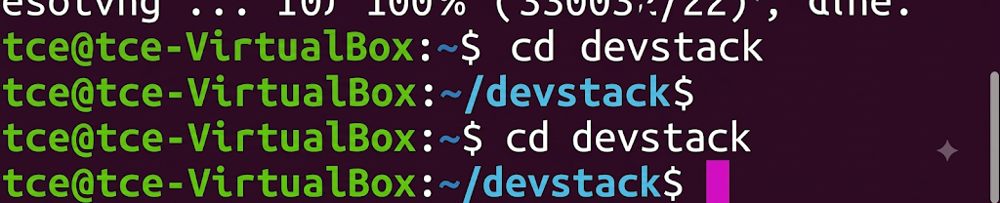
9)Change the configuration file in the local.conf
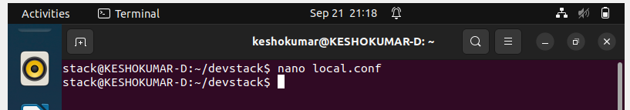
Update the below line and give password for each
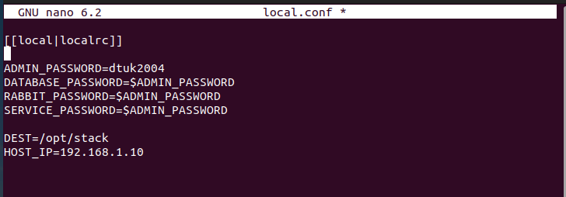
10)Run the openstack by the ./stack.sh
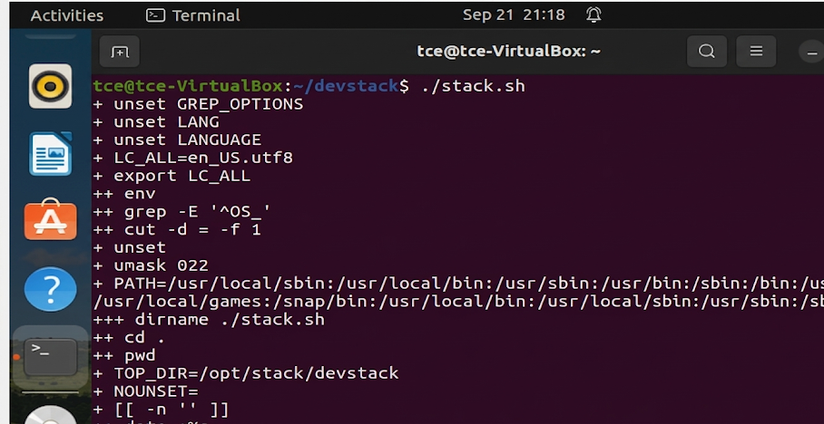

11) Visit the IP address that you have configured in the local.conf and login with the password configured in the local.conf
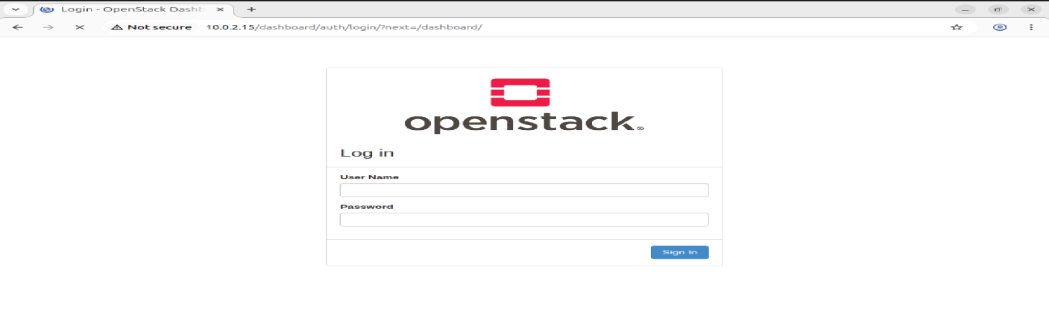
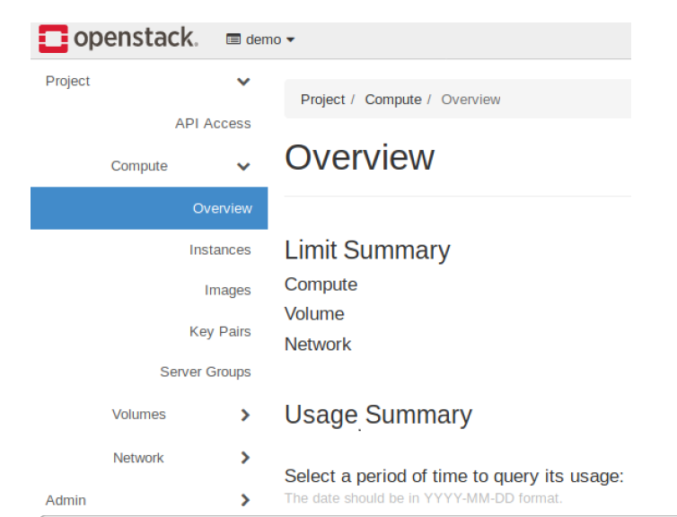
12) Create a Virtual Machine using openstack glace service using the following command
- Source OpenStack Credentials.
source devstack/openrc admin admin
(Replace admin with your actual project and username if different). Verify Image and Flavor.
- Checkout the image list
openstack image list
openstack flavor list
Note the name or ID of the image and flavor you intend to use.
- Create a Key Pair (if not already done):
openstack keypair create mykey > mykey.pem
chmod 600 mykey.pem
- Create a Network
DevStack typically creates a default network. You can list existing networks:
openstack network list. If you need to create a new one, this involves creating a network, subnet, and router, and connecting them. Launch the Virtual Machine.
openstack server create --image <image_name_or_id> --flavor <flavor_name_or_id> --nic net-id=<network_id> --key-name mykey my-first-vm
Replace <image_name_or_id>, <flavor_name_or_id>, and <network_id> with your chosen values. my-first-vm is the desired name for your VM. Verify VM Status and IP Address.
openstack server list
Look for your VM and its assigned IP address. Access the VM.
ssh -i mykey.pem cirros@<vm_public_ip>

Result:
Thus the installation of openstack and creation of virtual machine in linux system has been executed successfully and output has been verified.

